Documentation – Canvas LTI Integration

TL;DR: In order to be able to use Canvas for OAuth, the admin account of Canvas environment must create and LTI key to give the application a client_id. As of 03/24/2021, we are unable to attain an LTI key from Georgia Tech, thus we are unable to have an OAuth flow through Canvas.

This documentation will show the process of trying to make the JITI webapp accessible through Canvas OAuth.

1. The first resources looked at are a part of Emily Reese’s PowerPoint discussing LTI integrations.
   1. <https://utexas.instructure.com/courses/633028/pages/lti-tool-guidelines> - “Learning Tools Interoperability or LTI is a specification developed by the IMS Global Consortium to standardize the way external learning tools (apps) integrate with the Learning Management System, Canvas. Examples of LTI apps are iClicker, which when used can send clicker scores directly into your Canvas gradebook.”
   2. <https://pypi.org/project/lti/> - library to help develop Python LTI tools.
   3. <https://www.edu-apps.org/code.html> - brief introduction on how to write LTI applications
   4. <http://ltiapps.net/test/tc.php> - way to test LTI applications
   5. <https://www.imsglobal.org/specs/ltiv1p1p1/implementation-guide> - LTI specifications / documentations
   6. <https://oauth.net/core/1.0a/> - general documentation for OAuth
2. Other resources found later for further understanding of what was intended to be achieved by the Canvas Integration.
   1. <https://saltire.lti.app/platform> - a more updated way to help test LTI applications
   2. <https://canvas.instructure.com/doc/api/file.oauth.html> - specific documentation for Canvas LMS API and how OAuth should be approached.
   3. <https://github.com/ucfopen/lti-template-flask-oauth-tokens/blob/master/views.py> - code demonstrating the process of OAuth
   4. <https://github.com/dmitry-viskov/pylti1.3/wiki/Configure-Canvas-as-LTI-1.3-Platform> - the steps needed to enable an application to have a client_id / how to integrate your LTI application with Canvas.
3. Using Canvas LMS API
   1. Canvas’s LMS API is simple to use for most end points. You can either create a free account on Canvas’s website (canvas.instructure.com) as a teacher or request for a sandbox class where your GT account is considered the teacher. Then, go to the following page:

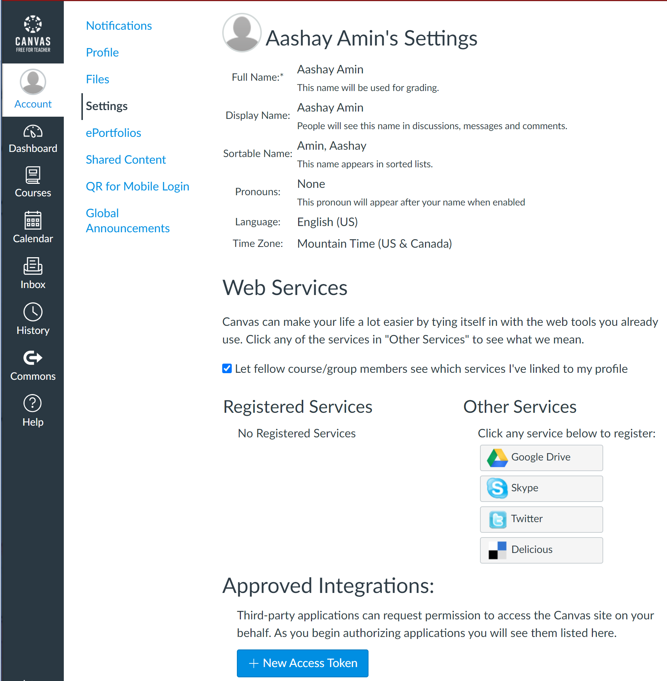

Clicking on “+ New Access Token” on the bottom will allow you to create an access token by which you can make API requests.

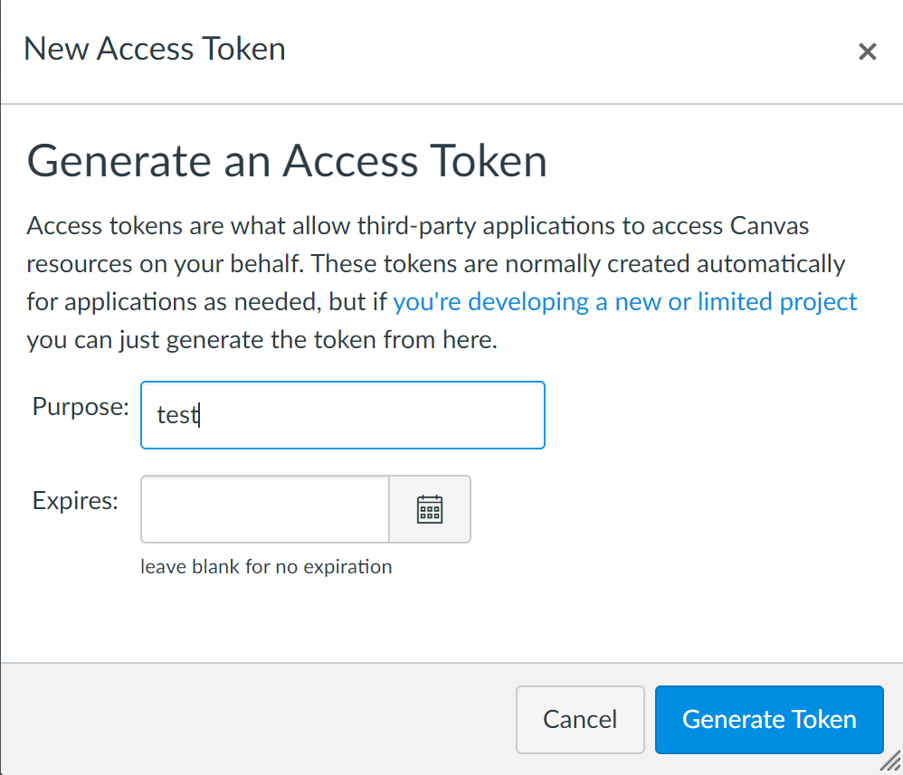

Then, click on generate token to get the next page.

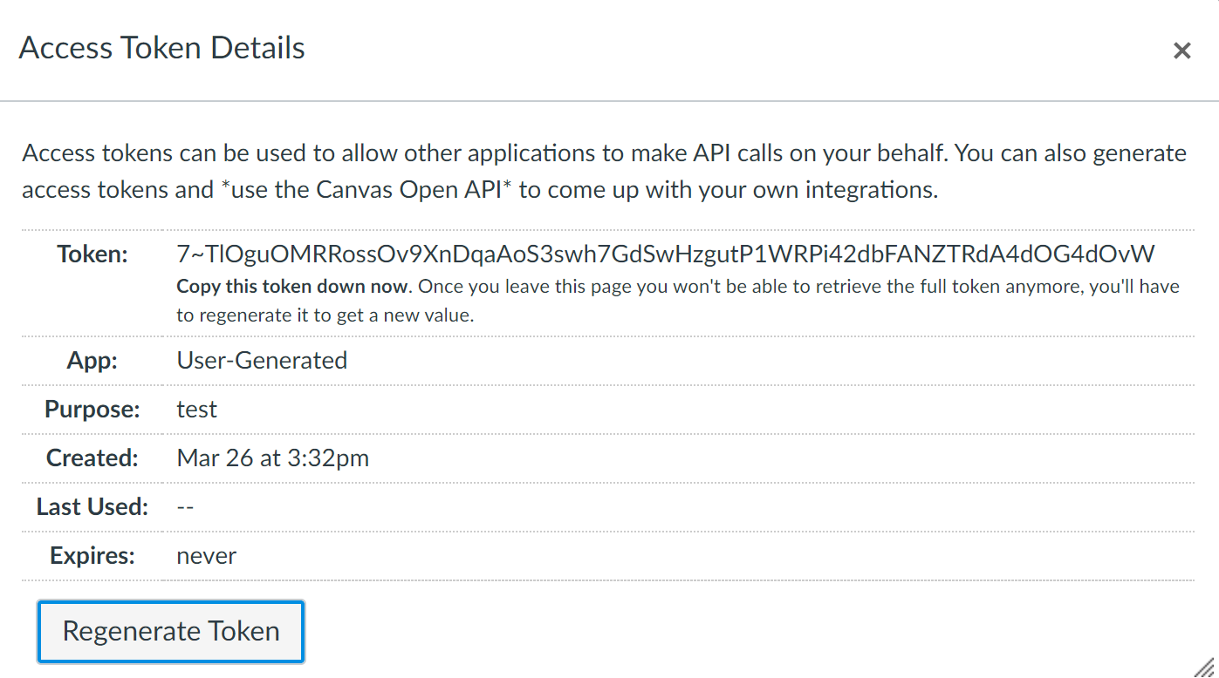

With this token, you can now make certain request from Canvas using its API. For example, from <https://canvas.instructure.com/doc/api/courses.html>, if we want to list our courses, the endpoint is

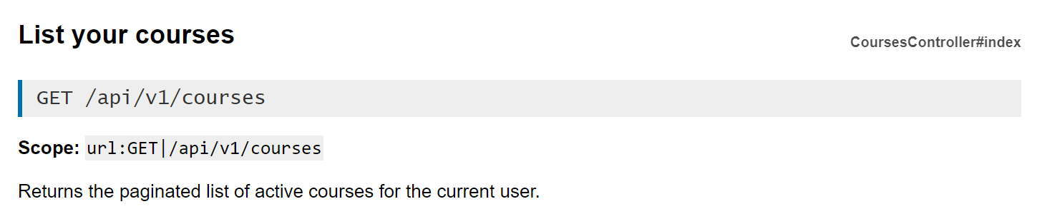

We can run a curl command in the terminal to test it out. Note the token needs to be part of an Authorization: Bearer header in order for the command to return anything.

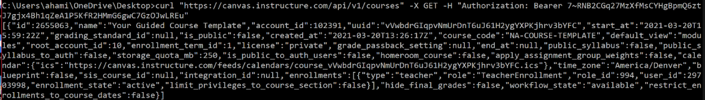

This is how you can use the Canvas LMS API for certain endpoints.

<https://raw.githubusercontent.com/dmitry-viskov/repos-assets/master/pylti1p3/examples/canvas-lms/002.png>

* 1. What if we want to use Canvas’s API for OAuth? According to Canvas’s documentation, here is what an example request looks like:

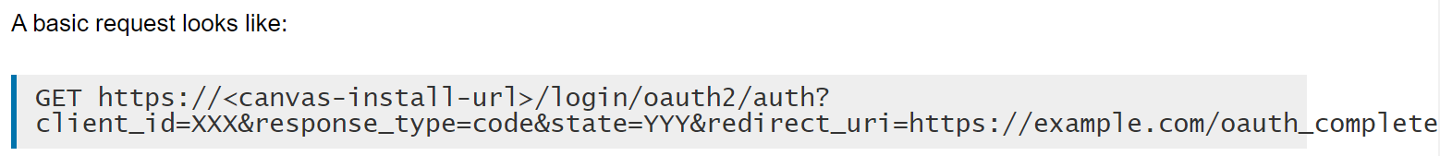

As can be seen, a client_id is needed to make the endpoint work. As per <https://github.com/dmitry-viskov/pylti1.3/wiki/Configure-Canvas-as-LTI-1.3-Platform>, the client_id needs to be generated by the admin by assigning an LTI key. Because the JITI subteam cannot acquire an LTI key as of now, we are unable to go through with doing OAuth through canvas.